SCHOOL DISTRICT NO. 62 (SOOKE)
3143 JACKLIN ROAD,
VICTORIA, BRITISH COLUMBIA • V9B 5R1
TELEPHONE: 250-474-9800 FAX: 474-9825
WEBSITE: WWW.SD62.BC.CA

October 16, 2014

Dear Parents and Guardians:

Last January the Board of Education updated its policy and regulations regarding volunteers in schools and parent drivers.

Ensuring student safety is of paramount importance to the Board and modernizing the policies that govern volunteers in schools was necessary.

The important changes surround the need for Criminal Review Checks (Vulnerable Sector) for any volunteers who work with students in an unsupervised setting. This means that volunteer drivers who do not have CRC’s cannot drive students on field trips. In fact, volunteer drivers must produce valid insurance, driver’s license, driver’s abstract and CRC according to Board policies.

As a result, some schools have not implemented the requirements, and schools and teachers may have to make alternative arrangements while awaiting documentation.

Although this change does require extra effort and patience, I am sure we all agree that student safety is worth it.

Yours truly,
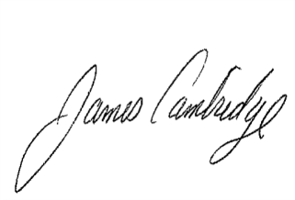
Jim Cambridge
Superintendent of
Schools

JC/jf

